Perladangan Kindersley

Dirujuk oleh
- 1915-06-30: Kindersley Brothers @ Ladang Balgownie
- 1929-03-07: Gabungan Ladang Balgownie dan Connemara
- Hospital Reko
- Sejarah Awal Bangi
- Sungei Ramal Estate (1907)

Ringkasan
Kiri: Dokumen-dokumen Ladang Kajang. Kanan: R.C.M. Kindersley. (Inch Kenneth Rubber Estates Limited, 2010: |"100 Years of Establishment").
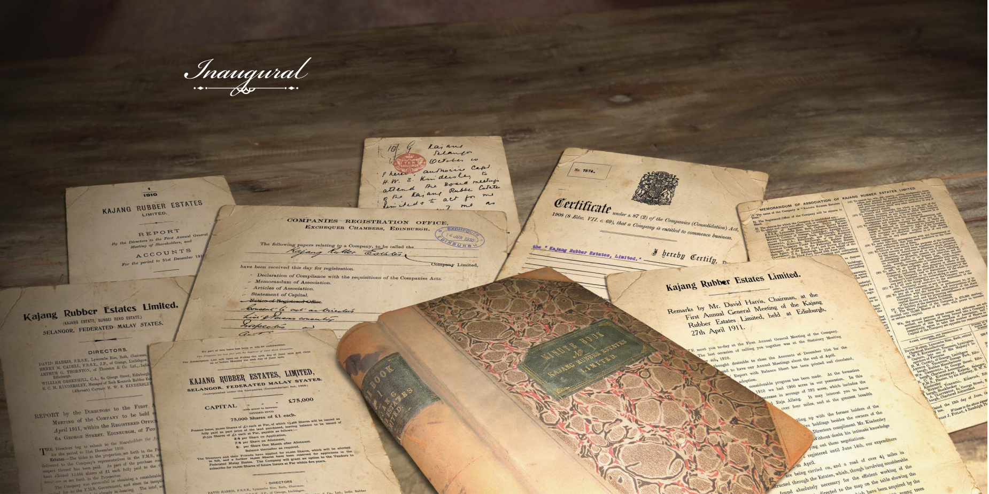Dokumen-dokumen Ladang Kajang
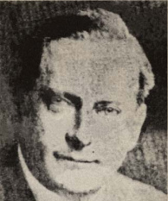R.C.M. Kindersley
“Ronald CM and Douglas CP Kindersley were among the first to experiment with soil conservation methods. The parent tree of clone PB 86 is well known as a parent of many modern clones and extensively planted in its day came from Kajang Estate. This tree, until a few years ago was especially protected by a fence constructed around it and could be seen on the left-hand side of the Kajang-Seremban road.” (VD Nair: |"The Story of Prang Besar Estate").

Riwayat Hidup
Perihal R(Ronald).C(Charles).M(Murray). dan D(Douglas).C.P. Kindersley:-
- 1870: R.C.M. Kindersley dilahirkan di Isle of Wight, England, sebelum berpindah ke Scotland.
- 1873: D.C.P. Kindersley dilahirkan.
- 1893: Berhijrah ke Selangor, Malaya, dan menjadi peladang kopi bersama Meikle bersaudara, di Wardieburn Estate, berdekatan Kuala Lumpur (The Singapore Free Press and Mercantile Advertiser, 21 July 1911, Page 5: |"WEDDING").
- 1894: Membuka ladang kopi Inch Kenneth di Kajang. Mungkin nama ladang adalah sempena Inch(Pulau) Kenneth, Scotland: “The development of pepper, coffee, and finally rubber estates in other parts of Selangor over the period 1880-1900 bypassed Ulu Langat until the mid-1890s, when improved communications made it a more attractive area in which to open an estate. The key factor was the extension southwards of the railway, which reached Pudu in 1893, Sungei Besi in 1895, and Kajang in 1897. When the Resident visited Kajang in 1894, he approved - with some formality to mark a significant event - two applications, each for 500 acres of land in the Ulu Langat district, made by European planters. These were the first such applications for estate land outside the Kuala Lumpur and Klang districts.” (J.M. Gullick, 2007: |"A Short History of Ulu Langat to 1900"), m.s. 16).
“The Inch Kenneth rubber estates comprise three properties - the Inch Kenneth, Reko Hill, and Dunedin - with a total area of 1,674 acres, of which 1,000 acres are under cultivation. The remainder is jungle, but this is being gradually opened up and planted. At first the estate was partly planted with coffee, but this has been superseded entirely by rubber. As an experiment two acres of land were planted ten years ago, but with this exception, the trees on the estate vary in age from those newly planted to those planted in 1902. Altogether there are 180,000 trees, and the crop of rubber in 1906 amounted to 2,000 lbs. It is estimated that about 5,000 lbs. will be produced in 1907. The manager's bungalow stands on a hill some 300 feet above sea-level, and commands a capital view of the surrounding country. Mr R.C.M. Kindersley has managed the estate since 1904, prior to which he was planting on the Kenneth estate. He employs Javanese coolies and has two assistants. The directors of the company are Messrs. D. Harris, G.B. Thornton, and Capt. H.W.S. Kindersley, and the secretaries are Messrs. Greenhill and Clapperton, of Edinburgh.” (Arnold Wright, 1908: |"Twentieth century impressions of British Malaya: its history, people, commerce, industries, and resources", m.s. 456).
Papan tanda Ladang Inch Kenneth, Kajang (Eric Lim @ Museum Volunteers, JMM, July 15, 2020: |"History of Kajang").
Kiri: Ladang Inch Kenneth, 1900-an (Edinburgh Geographical Institute, 1904 @ Yale University Library - Digital Collections: |"Selangor, Federated Malay States, 1904 / John Bartholomew & Co ; W.T. Wood, chief draftman").
Kanan: Gambaran kasar Ladang Inch Kenneth kini (Mapcarta).
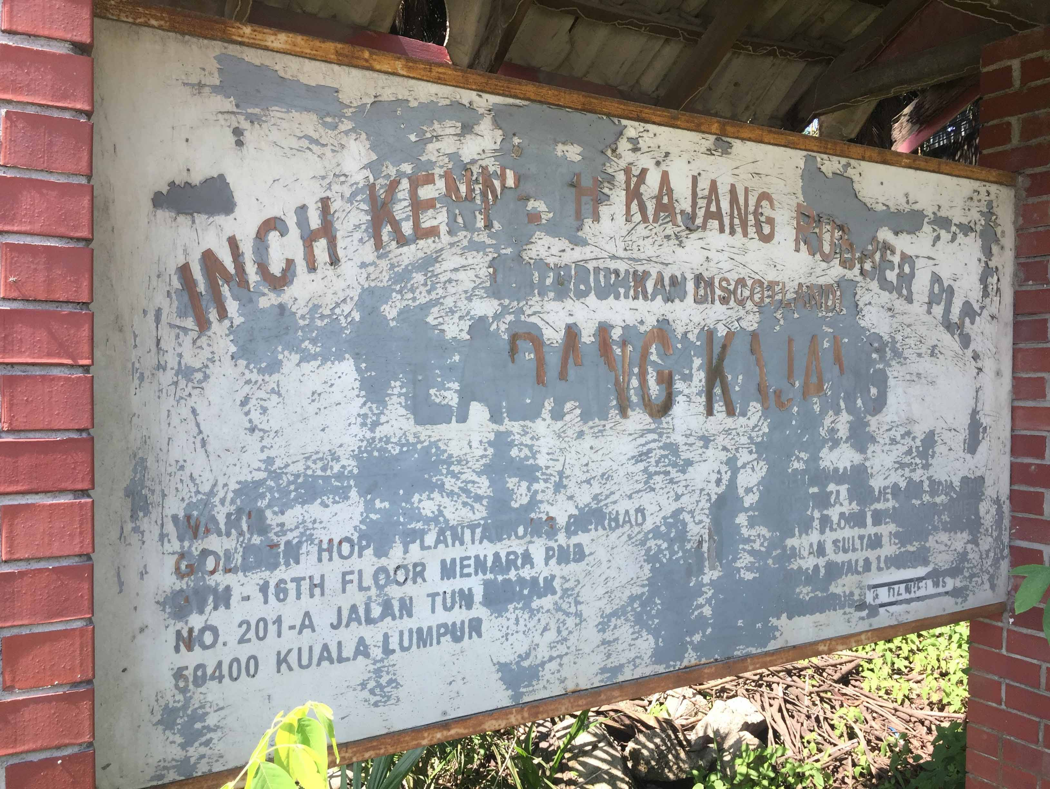Papan tanda Ladang Inch Kenneth, Kajang
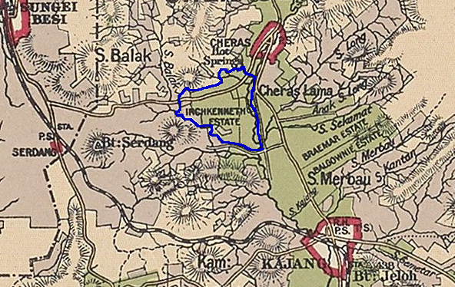Ladang Inch Kenneth, 1900-an
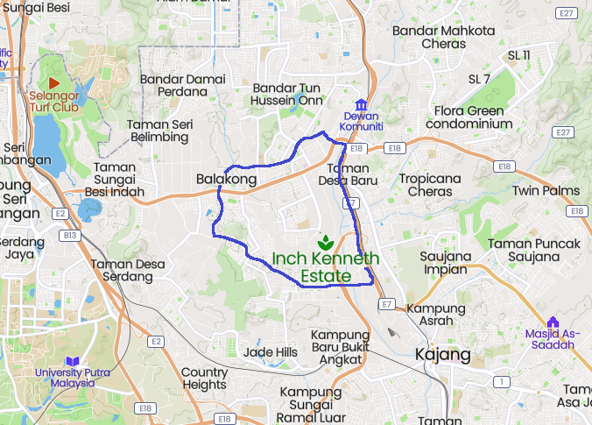Gambaran kasar Ladang Inch Kenneth kini
- 1896: Memperolehi anak pokok getah dari H.N. Ridley (Botanical Gardens, Singapura), lalu menanamnya di Ladang Inch Kenneth (berkeluasan 5 ekar), sebagai ladang getah pertama di Malaya: “The original purpose of the Kindersley brothers was to open coffee estates (free of the restriction to 250 acres in the Klang valley), but in 1896 H. N. Ridley, Curator of the Botanic Gardens in Singapore, supplied them with rubber seedlings to plant an experimental 5 acres on Inch Kenneth estate, near Kajang. They are generally credited with being the first to plant rubber on a commercial scale in Malaya. The collapse of the coffee industry in 1899 brought the Kindersleys to the brink of ruin but these dogged Scotsmen survived the crisis and went on to become prominent in the new industry. One of them, R. C. M. Kindersley, was an unofficial member of the FMS Federal Council in the 1920s. The example of the Kindersleys led to the creation of a group of estates, mostly within a mile or two of the railhead (1897) at Kajang. The Kindersleys owned Balgownie, Inch Kenneth, and Bangi estates. In 1898 Lau Boon Tit opened Semenyih estate, which was later acquired by the Asiatic Rubber Produce Company. Lau 'went for broke' in planting 54 acres of rubber in 1898. A few years later, the FMS Rubber Co. owned West Country, Belmont, and Ayer Hitam estates, and E. V. Carey, chairman of the Selangor Planters' Association, opened Paradise estate. Thus, for the first time, Ulu Langat became a flourishing 'planting district'. It was a turning point.” (J.M. Gullick, 2007: |"A Short History of Ulu Langat to 1900"), m.s. 16-17).
- 1904: R.C.M. Kindersley membuka ladang Reko Hill, kemudiannya mendiami sebuah banglo di sana (The Singapore Free Press and Mercantile Advertiser, 21 July 1911, Page 5: |"WEDDING").
- 1905: D.C.P. Kindersley menjadi pengurus Ladang Balgownie dan Bangi. Sebelumnya beliau mengurus ladang kopi dan getah di Negeri Sembilan. Tahun itu adalah kemuncak pembukaan ladang getah di antara Kajang dan Bangi, termasuk oleh R.C.M. Kindersley: “An application was made by Mr: R.C.M.Kindersley on behalf of the Inch Kenneth Rubber Estates Limited for 1000 acres of land for rubber planting between Reko and Bangi. If this application is approved, practically all the available land between Kajang and Bangi will be under rubber cultivation. - Ag: District Officer, Ulu Langat” (Arkib Negara 1957/0125542W, 03/11/1905: |"MONTHLY REPORT FOR OCTOBER, 1905 -").
- 1910: R.C.M. Kindersley menjadi pengarah syarikat Kajang Rubber Estates Limited.
- 1912: Membuka Hospital Reko, di bawah seliaan The Reko Hospital Association.
- 1914: Ladang Inch Kenneth dianugerahi pingat perak (Class I) di London Exhibition (Turut diumumkan oleh R.C.M. Kindersley di dalam mesyuarat ini. Ladang Balgownie dianugerahi pingat emas).
- 1915: Menutup Hospital Reko, setelah Hospital Kajang dibuka untuk seluruh warga terdekat.
- 1917: D.C.P. Kindersley meninggal dunia di medan perang dunia pertama, ketika berumur 44 tahun: “News has been received of the death in action of Capt. D. C. P. Kindersley, late of Kajang; … Captain Kindersley would have been forty-four years of age this year. He married the sister of Mr. E. W. Tyler, also of Kajang,…” (The Straits Times, 29 June 1917, Page 10: |"Untitled").
- 1917-1918: R.C.M. Kindersley dilantik sebagai pengerusi Planters' Association of Malaya.
- 1919 (31 Mac): Mengeluarkan beberapa (kesemua?) estet beliau dari Kajang District Planters Association (The Straits Times, 16 April 1919, Page 10: |"Kajang D.PA":-
Kiri: Ladang-ladang Kindersley di selatan Kajang, 1920-an (Survey Department, Singapore, 1927 @ National Archives of Singapore: |"Parts of Seremban and Jelebu Districts with portions of Ulu Langat and Kuala Langat Districts (Selangor), Kajang, Negri Sembilan").
Kanan: Gambaran kasar bekas ladang-ladang Kindersley di selatan Kajang, kini (Mapcarta).
Senarai penuh:-
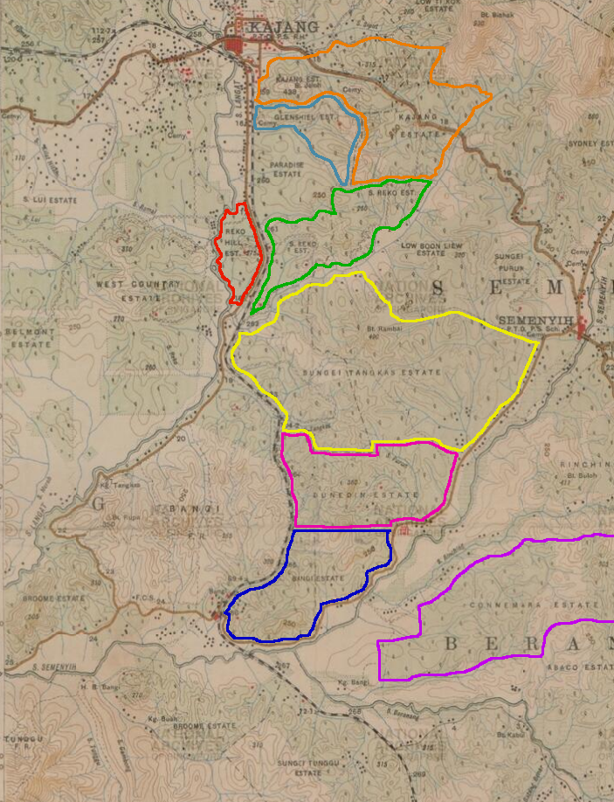Ladang-ladang Kindersley di selatan Kajang, 1920-an
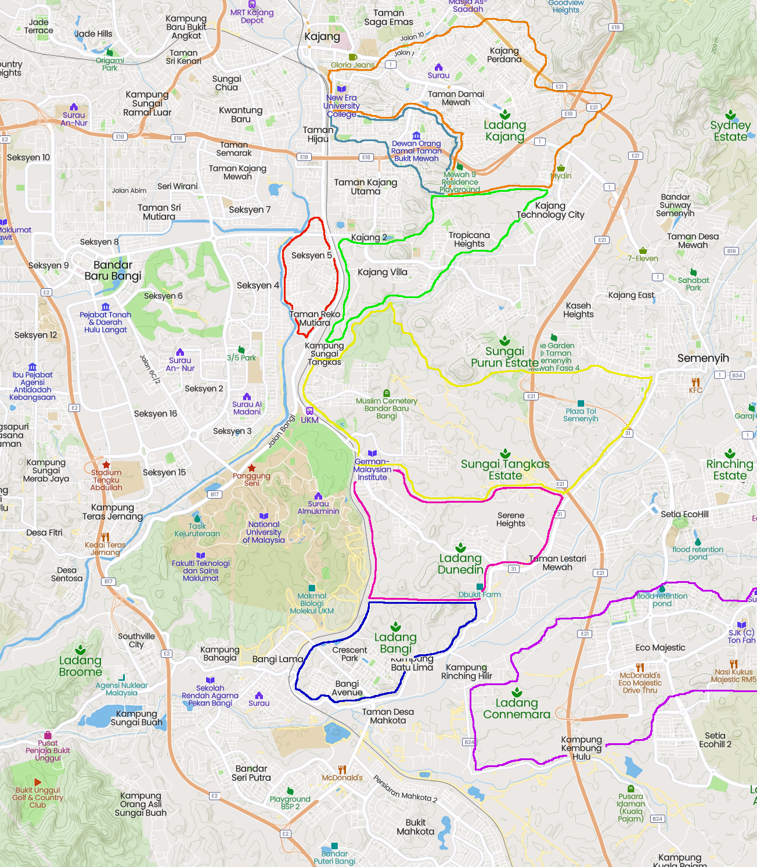Ladang-ladang Kindersley di selatan Kajang, kini
  - Balgownie Estate (Sebelah utara peta)
  - Bangi Estate (Kini Taman Bangi Indah, Bangi Avenue, Crescent Park)
  - Inch Kenneth Estate (Sebelah utara peta)
  - Dunedin Estate (Kini Alam Sari, Serene Heights)
  - Reko Hill Estate (Kini Bandar Baru Bangi Seksyen 5, SJK(T) Ladang West Country Timur, SMK Jalan Reko, Taman Tenaga, Taman Langat Jaya, Pusat Hentian Kajang, Taman Perindustrian Kajang)
  - Gleshiel Estate (Kini Taman Bukit Mewah, Taman Sri Mewah, Taman Bukit Mutiara)
  - Sungei Tankas Estate (Kini Kg Sg Tangkas,
  - Kajang Estate (Kini Taman Bukit Indah, New Era University College, Taman Kajang Prima, Taman Damai, Taman Jasmin, Taman Cantik, Taman Ria, Taman Sentosa, Taman Asa Jaya, Taman Sri Jelok)
  - Sungei Reko Estate (Kini Kajang 2, Kajang Villa, Tropicana Heights, Rafflesia International School, Taman Anggerik Emas)
  - Connemara Estate (Kini Eco Majestic)
  - Sungei Ramal Estate (Sebelah barat laut peta)
- 1921: Dilantik sebagai pegawai Straits Settlements Trade Commission.
- 1926: Bersama Haji Abdul Jalil, Low Ti Kok, Raja Muhammad dan Ng Seow Buck, mengusahakan tapak baru sekolah British di Kajang bagi menggantikan bangunan yang telah usang. Tapak yang ditetapkan terletak di Jalan Semenyih, seluas 28 ekar. Bangunan sekolah baru ini siap dibina dan dibuka pada tahun 1930, dan kini dikenali sebagai Sekolah Menengah Kebangsaan Tinggi Kajang (Kajang High School) (LATAR PERISTIWA: Perihal Kajang High School (KHS)).
- 1929: Bersara dan kembali ke England.
- 1939: R.C.M. Kindersley meninggal dunia (pneumonia). Berumur 68 tahun.
(Sumber utama: Inch Kenneth Rubber Estates Limited, 2010: |"100 Years of Establishment")
PERIHAL LANJUT: Inch Kenneth Estate (1894)

Perkembangan Syarikat
Setelah peninggalan R.C.M. Kindersley, syarikat Inch Kenneth terus berkembang sehingga kini. Antara peristiwa penting berkaitan Bangi dan sekitarnya:-
- 1933: Kajang Rubber Estates digabungkan dengan Inch Kenneth Estates, menjadi Inch Kenneth Kajang Rubber Limited.
- 1973: |Straits Trading Co Limited memperolehi majoriti saham (28%).
- 1974: Salah satu daripada ladang mereka, Ladang Dunedin di Bangi, menjadi ladang pertama mereka yang ditukar dari getah kepada kelapa sawit. (Kemungkinan nama ladang ini adalah sempena nama asal Edinburgh, Scotland).
Lokasi Ladang Dunedin, Bangi.
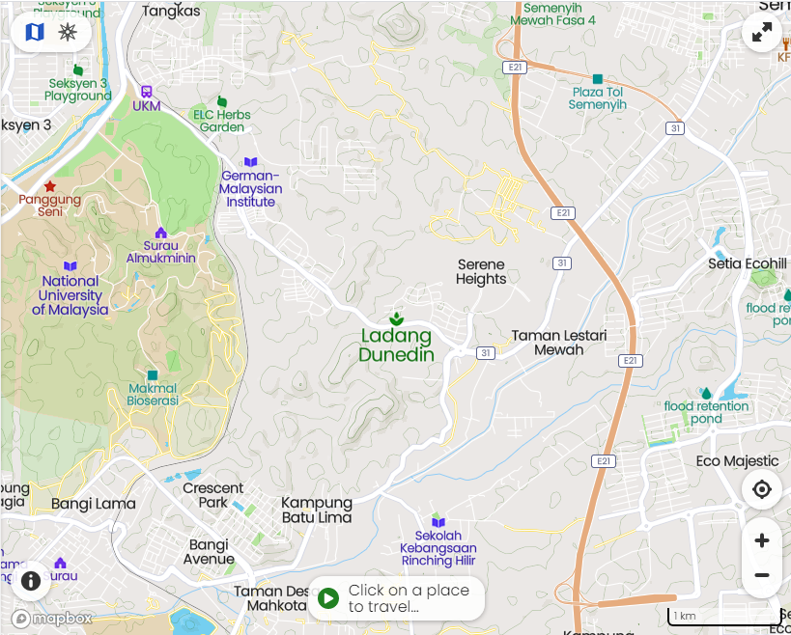Lokasi Ladang Dunedin, Bangi
- 1978: Syarikat kini berpindah dari UK ke Malaysia, beribu pejabat di Tingkat 5, Floor Straits Trading Building, 4 Leboh Pasar Besar, Kuala Lumpur.
- 1982: Didaftarkan sebagai Inch Kenneth Kajang Rubber Public Limited.
- 1984: 600 ekar tanah di Kajang dijual kepada Malaysian Resources Corporation Berhad (MRCB).
- 2001: 350 ekar tanah di Kajang mendapat kebenaran penukaran status, dari ladang kepada pembangunan pelbagai.
Kawasan Ladang Kajang yang bakal dibangunkan.
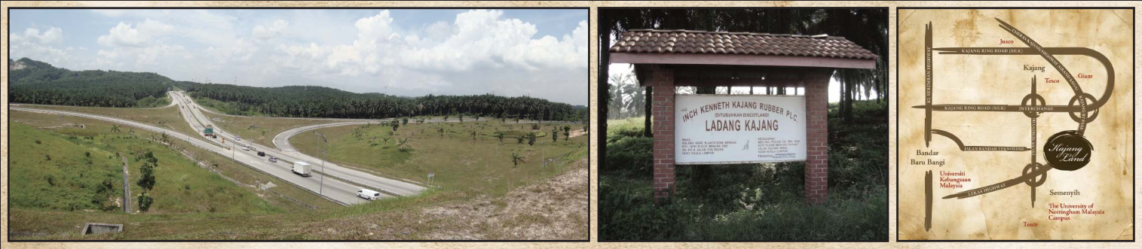Kawasan Ladang Kajang yang bakal dibangunkan.
- 2005: Hasil penilaian semula, tanah mereka di Kajang dan Bangi kini bernilai RM258 juta.
- 2007: 600 ekar tanah di Bangi mendapat kebenaran penukaran status kepada pembangunan pelbagai.
Kawasan Ladang Dunedin, Bangi yang bakal dibangunkan.
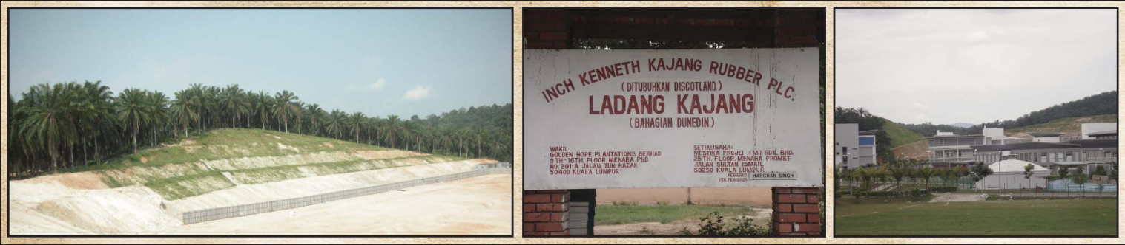Kawasan Ladang Dunedin yang bakal dibangungkan.
Sumber utama: Inch Kenneth Rubber Estates Limited, 2010: |"100 Years of Establishment")

Era Pemaju
Setelah perubahan penukaran status tanah kepada pembangunan, syarikat-syarikat pemaju mula mengambil alih pengurusan atau pemilikan ladang-ladang. Penduduk dan pekerja asal Ladang Dunedin mula diberhentikan dan dipindahkan. Kehidupan masyarakat yang telah mengakar berpuluh tahun di ladang, seolah dicabut terus. Di bawah pengurusan dan matlamat baru pemaju, sejarah perkhidmatan, perjanjian, serta hak-hak kehidupan mereka seringkali terpinggir atau terlupus, lalu menimbulkan beberapa masalah dan kesan yang berpanjangan (contohnya di Ladang Dunedin: masalah berlarutan selama 5 tahun: 2008-2013):-
- 2008: “There is strength in numbers which is why PSM secretary-general and Kajang Municipal councillor S. Arutchelvan wants to mobilise together the estate workers of Semenyih, Dunedin, Bangi and Glengowrie to demand for housing. 'Breaking up the communities of estate workers leads to a negative impact on their psyche as they already feel neglected and cast aside,' Arutchelvan said. 'With a proper area set aside for housing, displace estate workers can ask for a school, hall and places of worship,' he said.” (Geetha Krishnan @ The Star, 17 Jul 2008: |"Thousands of former estate workers in dire need of work and shelter").
- 2011: “Hari ini 9 orang pekerja ladang Denudin, batu 3 1/2 jalan Bangi telah menerima notis berhenti kerja. Ini merupakan ladang terakhir di Semenyih menerima notis. Notis diberikan oleh wakil Tuan Ladang Inch Kenneth. Ini merupakan ladang ulung Inch Kenneth. Notis ini memaklumkan bahawa tarikh akhir mereka berkhidmat adalah 31 Mei 2011. Selain itu notis itu langsung tidak berbincang bayaran ex-gratia dan perumahan alternatif.” (PSM Semenyih, 11/4/2011: |"6-4-11 Ladang terakhir di Semenyih Terima Notis berhenti kerja").
- 2013: Perjanjian ditandatangani oleh Inch Kenneth: 22 orang bekas pekerja Ladang Denudin akan mendapat rumah alternatif percuma sebagaimana sewajarnya, setelah beberapa mesyuarat telah diadakan antara pemaju, pemilik dan ahli jawatankuasa pekerja ladang, serta pejabat SUK Negeri Selangor. (Rajan, PSM Semenyih @ Anjung Kiri, February 8, 2013: |"22 Keluarga Dapat Rumah Percuma: Ladang Denudin Semenyih").

Nasib Penduduk Asal
Masalah penduduk di Ladang Bangi (yang telah/pernah bergabung dengan Balgownie), berlarutan lebih lama lagi, selama 9 tahun: 2000-2019 (pemilik asal: Sime Darby):-
- 2012: Ladang Bangi yang berhenti beroperasi pada tahun 2000, telah diambil alih oleh syarikat pemaju lain tanpa pengetahuan penduduk, dan kerja-kerja penebangan pula telah dijalankan, tanpa memenuhi syarat-syarat terdahulu. Walaupun aduan dibuat, tindakan pihak berwajib cenderung menyebelahi pihak pemaju. (Krishnan a/l Chendermaie, Pengerusi JK Bertindak Ladang Bangi @ PSM Semenyih, 23/4/2012: |"Pekerja Ladang Bangi buat aduan terhadap 3 syarikat").
Lokasi Tapak Projek Pembangunan Bercampur di atas Lot 1913, Ladang Bangi, seluas 342.49 ekar (138.6 hektar), untuk dimajukan oleh Seriemas Development Sdn. Bhd. (Europasia Engineering Services Sdn. Bhd., 2015: |"EIA for the Proposed Mixed Development on Lot 1913, Bangi Estate, Mukim Semenyih, District of Hulu Langat, Selangor Darul Ehsan for Seriemas Development Sdn. Berhad: Ringkasan Eksekutif, m.s.3).
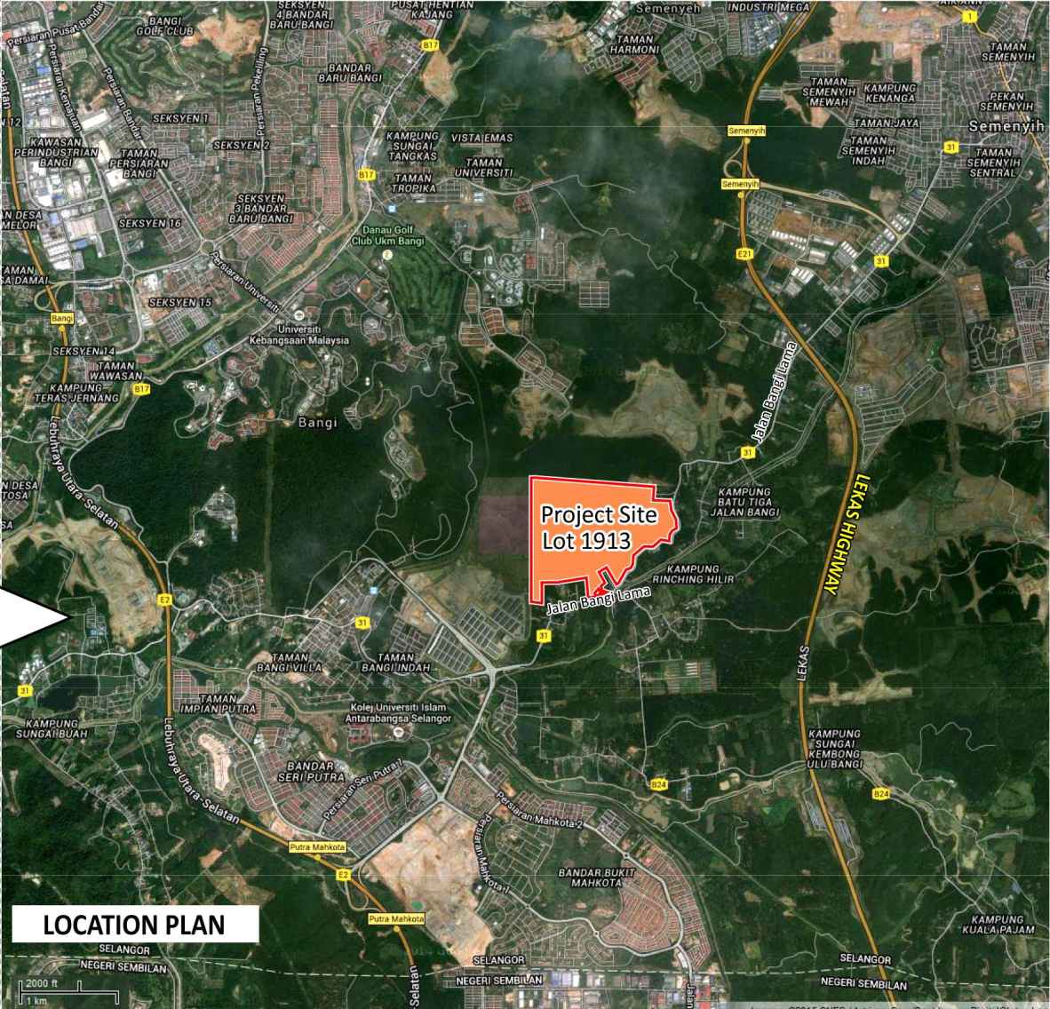Tapak Projek Ladang Bangi
- 2017: Setelah 17 tahun bergelut dengan samseng kontaktor pemaju, janji-janji yang dimungkiri, dan beberapa sesi di mahkamah, akhirnya 24 keluarga Ladang Bangi menandatangani perjanjian jual beli rumah mereka dengan pihak pemaju Trans Loyal Development Sdn Bhd. (Annabelle Lee @ Malaysiakini, 31 May 2017: |"End of 17-year suffering for Ladang Bangi folk").
Majlis sambutan kemenangan perjuangan perumahan di Ladang Bangi, 27 Ogos 2017 (Sosialis, Sep-Okt 2017, m.s.5: |"Majlis sambutan kemenangan perjuangan bekas pekerja Ladang Bangi").
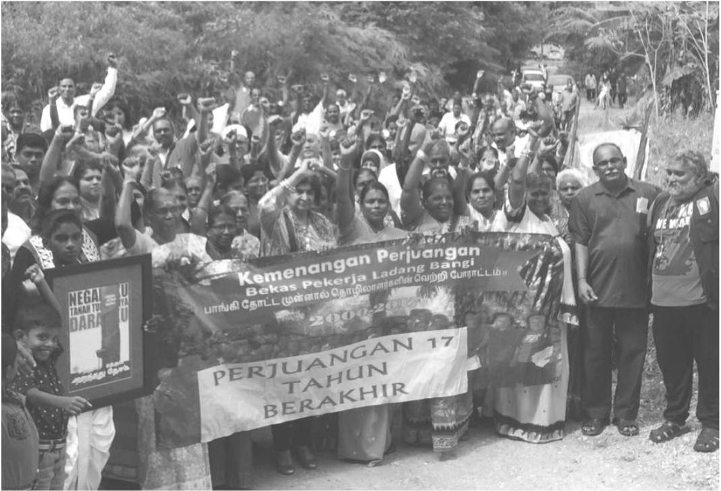Majlis sambutan kemenangan perjuangan perumahan di Ladang Bangi, 27 Ogos 2017
- 2019: 2 tahun selepas perjanjian tersebut, 24 keluarga ini menerima kunci rumah daripada pihak pemaju Trans Loyal Development Sdn Bhd. (Tarrence Tan @ The Star, 20 Feb 2019: |"24 families of estate workers given new homes in Semenyih") (Sumber lain: Ahmad Ismadi Ismail @ Sinar Harian, 20 Februari 2019: |"Penantian 17 tahun, 24 keluarga bekas pekerja ladang berakhir"). Namun masalah lain pula timbul: mungkin pihak pemaju merasakan mereka telah menunaikan janji mereka, lalu bertindak menutup laluan ke kuil Ladang Bangi (padahal kuil itu telah pun diwartakan di bawah kerajaan negeri):-
  - Sosialis, 16/5/2019: |"Pemaju Transloyal sekat laluan masuk ke Kuil Ladang Bangi"
  - S. Arutchelvan @ Sosialis, 16/5/2019: |"Mengapa MPKj tidak bertindak? Mengapa pemaju begitu kebal?"
  - Sosialis, 17/5/2019: |"Laluan masuk Kuil Ladang Bangi dibuka semula"
Bacaan lanjut mengenai nasib penduduk asal sesuatu tempat (penduduk kampung, pekerja ladang, dll), serta kesan terhadap keluarga, budaya, dan sosioekonomi mereka, setelah tanah yang mereka duduki diambil alih untuk pembangunan, oleh syarikat swasta mahupun kerajaan:-
- Selvi Narayanan, Katiman Rostam, 2012: |"Impak sosial pembangunan Bandar Baru Putrajaya terhadap penduduk asal: Kes isi rumah yang dipindahkan ke Taman Permata, Dengkil, Selangor" (PDF).
- Andrew C. Willford, S. Nagarajan, 2015: |"Tamils and the Haunting of Justice: History and Recognition in Malaysia's Plantations", m.s. 108-118 (PDF).
- Zawawi Ibrahim, 2016: |"Anthropologizing Human Insecurities: Narrating the Subjugated Discourse of Indigenes on the Deterritorialized Landscapes of the Malaysian Nation-State".
- Mangai Balasegaram @ Between The Lines, Nov 8, 2020: ||"Different Class: The Marginalisation of Indians in Malaysia".
LATAR PERISTIWA: Getah di Malaya.
Pengakuan penting: Kami bukan ahli sejarah! Sila klik di sini untuk penjelasan lanjut.
Laman Utama | 1900-1909 | 1910-1919 | 1920-1929 | 1930-1939 | 1940-1949 | 1950-1959 | 1960-1969 | 1970-1979 | 1980-1989 | 1990-1999
Siri Cebisan Sejarah: | Bangi | Gambang | Hutan | Ipoh | Kajang | Kuala Lumpur | Kuantan | Pulau Pinang | Hubungi Kami
Selain petikan dan sumber yang dinyatakan, rencana ini telah diusahakan oleh TMK Pulasan, di bawah kelolaan Syahrul Sazli Shaharir <sazli@pulasan.my>. Pengakuan penting: Kami bukan ahli sejarah! Sila klik di sini untuk penjelasan lanjut.

