Arthur Bligh (A.B.) Stephens (1855-1908)

Dirujuk oleh
- Hutan Simpan Ayer Itam (1905-kini)
- Hutan Simpan Bangi (1906-kini)

Sejarah Ringkas
Salasilah keluarga A.B. Stephens (Anne Lister's Society, November 2020: |"The Belcombe Family of York": |"The Belcombe Family Tree").
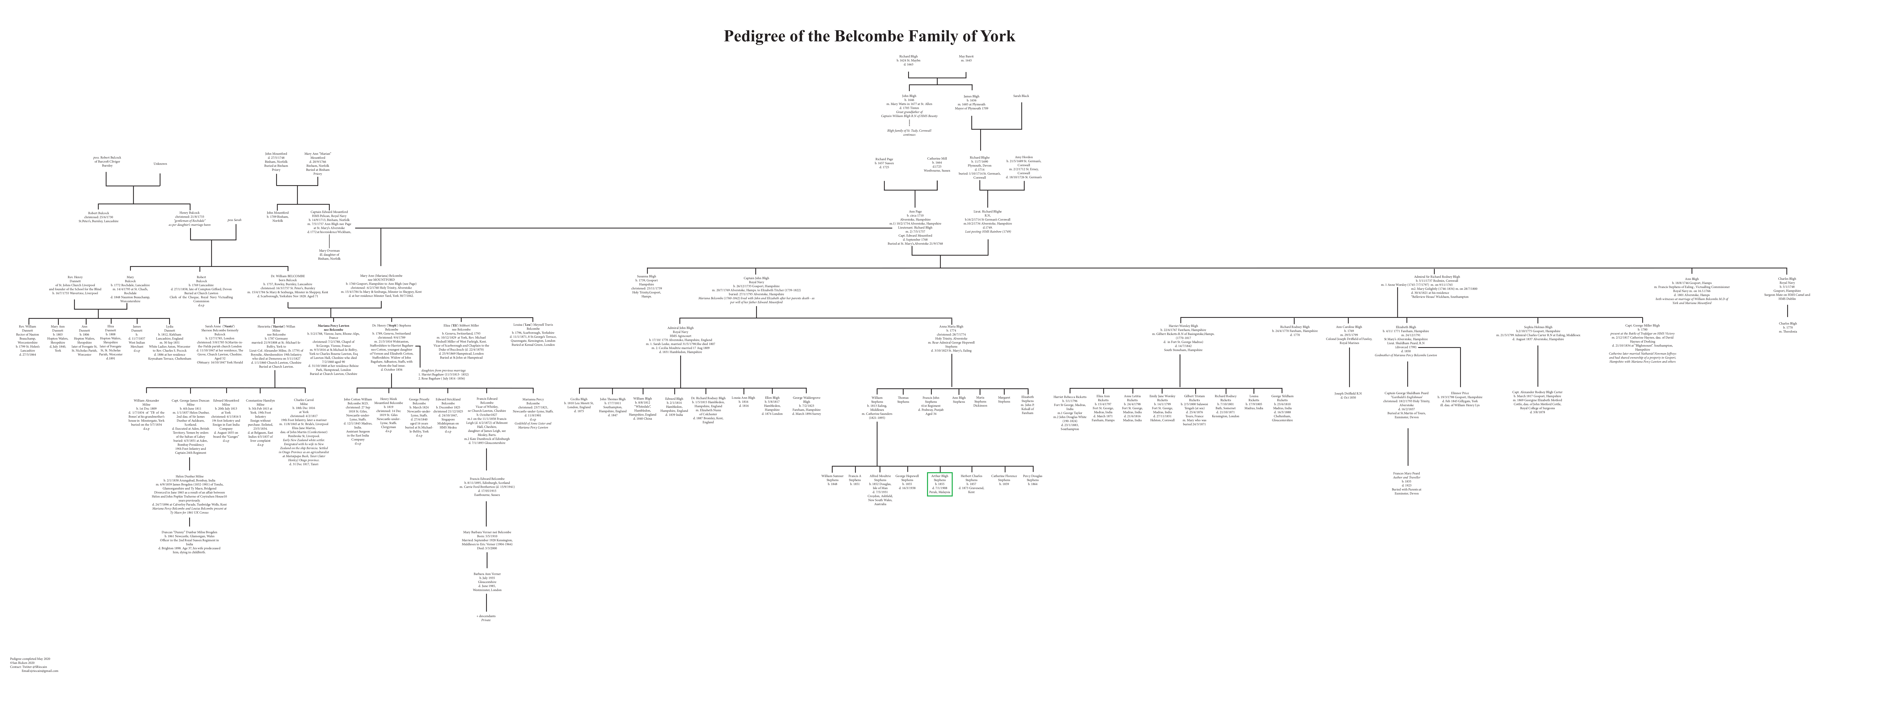Salasilah keluarga A.B. Stephens
- 1855 (31 Oktober): Dilahirkan di Isle of Man. Mendapat pendidikan awal di Godolphin School, Hammersmith: “b. Oct. 31, 1855.” (|"Who’s Who in the Far East 1906-7", m.s. 388). “Mr. Arthur Bligh Stephens, Deputy Conservator of Forests, Perak, has the distinction of being the oldest European resident in the Federated Malay States. Born in the Isle of Man in 1855, and receiving his education at Godolphin School, Hammersmith…” (Arnold Wright, 1908: "Twentieth century impressions of British Malaya: its history, people, commerce, industries, and resources", m.s. 336). Beliau adalah anak kelima pasangan William dan Catherine Saunders Stephens. Abang beliau, Frank A. Stephens (anak kedua, dilahirkan tahun 1849), bertugas di Jebong Estate, Perak (Chris Nelson @ Find a Grave, 9 Mar 2010: |"Arthur Bligh Stephens").
- 1872: Datang ke Malaya sebagai penanam ubi kayu di Province Wellesley (Seberang Perai): “…he first came to Malaya in 1872, and commenced tapioca planting in Province Wellesley.” (Arnold Wright, 1908: "Twentieth century impressions of British Malaya: its history, people, commerce, industries, and resources", m.s. 336).
- 1872-1878: Penanam tembakau di Sumatra: “Subsequently he was engaged in tobacco planting in Sumatra for six years.” (Arnold Wright, 1908: "Twentieth century impressions of British Malaya: its history, people, commerce, industries, and resources", m.s. 336).
- 1881: Abang beliau, Frank A. Stephens tiba di Malaya, kemudiannya mengusahakan tanaman tembakau di Deli, Sumatera sehingga kembali ke Malaya pada tahun 1891. 1-2 tahun selepasnya (1892-1893) beliau membuka Jebong Estate, bagi mengusahakan tanaman kopi dan kelapa. Antara penanam awal getah di ladang tersebut sekitar 1898-1899: “Mr. Stephens arrived here in 1881, after some years in the mercantile marine. He crossed over to Deli, where he was engaged in tobacco planting until 1891, when he returned to the Native States. He was engaged as a contractor for a year or two, and then, with Mr. L. Watson and Mr. McGillivray, opened up the Jebong Estate with coffee and coconuts. This Estate was the first to start planting rubber six or seven years ago.” (Straits Echo, 1 November 1905, Page 4: |"Death of Mr. F. A. Stephens").
- 1892: Pembantu Ejen Imigresen India: “Asst. Indian Immigration Agent, 1892;” (|"Who’s Who in the Far East 1906-7", m.s. 388).
- 1893: Pemangku Superintenden Perladangan Kerajaan: “acting Supt, of Govt. Plantations, 1893;” (|"Who’s Who in the Far East 1906-7", m.s. 388).
- 1895: Pegawai Perhutanan, seterusnya Deputy Conservator of Forests Selangor: “Forest Officer, 1895; Deputy Conservator of Forests Selangor” (|"Who’s Who in the Far East 1906-7", m.s. 388).
- 1896 (10 Mac) - 1897: Sebagai Pegawai Perhutanan Perak (antara pegawai awal Jabatan Perhutanan), beliau dihantar ke Calcutta untuk meneliti perkembangan jabatan-jabatan perhutanan di seluruh India: “Mr. Arthur B. Stephens, the Forest Officer in Perak, has left for Calcutta. Mr. Stephens has been sent by the Perak Government to acquire a thorough insight into the latest development of the Forestry departments throughout India. He will probably be absent about a year.” (Straits Budget, 10 March 1896, Page 5: |"FORESTRY IN PERAK"). “After acting as Superintendent, Government Plantations, he became a Forest Officer in 1895. He was thus one of the first officers of the Forest Department, and he went to India to study forestry there.” (The Singapore Free Press and Mercantile Advertiser (Weekly), 16 January 1908, Page 37: |"F. M. S. NOTES").
- 1900 (6 Disember): Menghadiri majlis makan malam tahunan Straits Settlements Association di Whitehall Rooms, London, England (The Straits Times, 10 January 1901, Page 3: |"STRAITS SETTLEMENTS ASSOCIATION").
- 1903: Deputy Conservator of Forests, Perak. Kemudiannya Acting Conservator of Forests Perak selama setahun: “In 1903 he received the Federal appointment of Deputy Conservator of Forests, Perak, and later he acted for a year as Conservator of Forests during Mr Burn-Murdoch's absence on leave.” (The Singapore Free Press and Mercantile Advertiser (Weekly), 16 January 1908, Page 37: |"F. M. S. NOTES").
- 1905 (25 Oktober): Abang beliau, Frank A. Stephens, meninggal dunia selepas menjalani pembedahan di London, England: “It is with greatest regret that we have to report the receipt of a telegram yesterday by Mr. William Stephens, announcing the death of his uncle, Mr. Frank Stephens, after a surgical operation performed upon him in England, says Monday's Pioneer. … Mr. Stephens, who was aged 56 at the time of his demise, … We have to offer our sincerest sympathy and condolences with his brother, Mr. Arthur Stephens…” (Straits Echo, 1 November 1905, Page 4: |"Death of Mr. F. A. Stephens"). “…his dear friend and elder brother Frank A. Stephens, of Jebong Estate, Perak, who died in London, 25th October 1905.” (Chris Nelson @ Find a Grave, 9 Mar 2010: |"Arthur Bligh Stephens").
- 1906 (20 Ogos): Percutian ke Australia untuk bertemu saudara kandungnya: “Mr. Arthur Stephens left Taiping on Friday last on three months' holiday to Australia where he expects to meet a brother he has not seen for nearly thirty-six years. During Mr. Stephens' absence Mr. H. Farnivall from Batu Gajah will act as Conservator of Forests, Perak.” (Straits Echo, 20 August 1906, Page 4: |"PERAK NOTES").
- 1906 (16 Oktober): Ahli Perak Club: “As regards the bowling alley he requested Mr. Moss to explain what had been done. Mr. Moss said that Mr. Arthur Stephens had written to Penang on the subject and received a reply to the effect that they in Penang were disappointed with their alley which was too short. He suggested awaiting Mr. Arthur Stephens' return, which would not be long, before proceeding further with the matter.” (Straits Echo, 16 October 1906, Page 4: |"Perak Club").
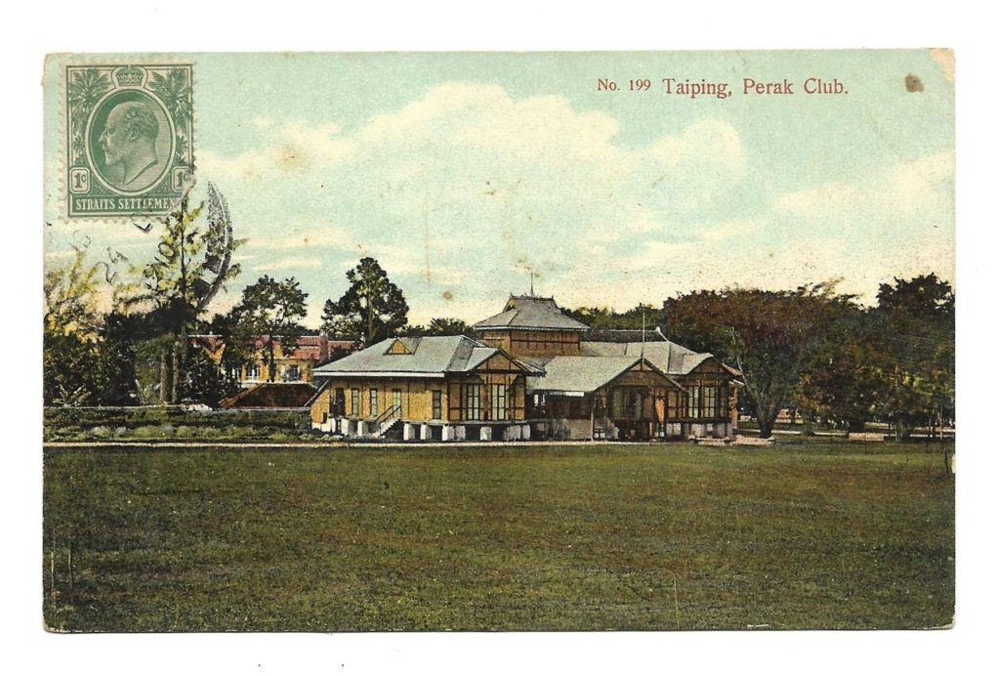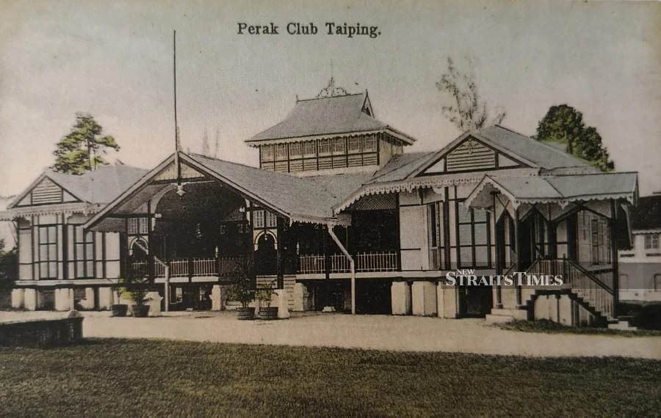
Perak Club, Taiping (Kiri: A. Kaulfuss, 1910 @ Farish Noor Collection, Malaysia Design Archive: |"TAIPING, PERAK CLUB"; Kanan: Alan Teh Leam Seng @ New Straits Times, April 28, 2019: |"Taiping's everlasting heritage").
- 1908 (7 Januari): Meninggal dunia di European Hospital Taiping, Perak: “Mr. Arthur Bligh Stephens, of the Forestry Department of the F.M.S. Government, died at the European Hospital, Taiping, on the 7th inst. The deceased gentleman, who was 52 years of age, suffered from heart trouble. … The funeral took place the same evening at the All Saints' Church Cemetery, Taiping, and was attended by all European officials and nonofficials in Taiping, as well as prominent Eurasian and native residents of the town. The coffin, which was borne on a gun carriage drawn by a detachment of gunners of the Malay States Guides, was literally covered with wreaths, crosses, and other floral tributes. They were indeed so numerous that some had to be conveyed in a separate vehicle which followed the gun carriage.” (Straits Budget, 16 January 1908, Page 10: |"Death of F.M.S. Official").
“We regret to announce the death of Mr Arthur Bligh Stephens, which took place this morning at 6 o'clock in the European Hospital Taiping. He only returned from leave in Australia about a year ago, and had since been suffering from heart trouble. Mr Stephens, who was fifty-two years of age, entered the Government service in 1892 as Assistant Indian Immigration Agent.” (The Singapore Free Press and Mercantile Advertiser (Weekly), 16 January 1908, Page 37: |"F. M. S. NOTES").

Peninggalan
A.B. Stephens telah dikebumikan di All Saints Church Cemetery, Taiping, Perak. Di dalam mesyuarat Perak Club pada Selasa 18 Februari 1908, beberapa cadangan dikemukakan bagi memperingati jasa-jasa beliau mencantikkan persekitaran Taiping (terutamanya Taman Tasik Taiping). Selain tablet peringatan di gereja All Saints itu (kemungkinan yang kekal sehingga kini dalam gambar di bawah), turut dicadangkan ialah piala kejohanan golf dan binaan pancuran air sempena beliau: “A meeting was held at the Perak Club on Tuesday to concert measures for perpetuating the memory of the late Mr. A. B. Stephens. The Resident, Colonel Walker, Messrs. Barnard, Mager, Alexander, Moss, Brearley, Tate, Sayers, Pedley, Talbot and Mills were present. On the motion of Colonel Walker, the Resident took the chair and he spoke feelingly of the deceased gentleman, and paid a tribute to the excellent services rendered by him in beautifying the town, especially the gardens, the lake and the golf links, and his prowess at the royal game. He said he would be long remembered in connection with these. As a memorial tablet would be put up by his brother officers at the Church, he suggested that to further commemorate his memory, a Stephen's Memorial Challenge Cup be instituted and competed for by all the Golf Clubs in the F.M.S. This proposition was unanimously carried. Mr. Moss then proposed that a brass fount be placed in the Church to the memory of both brothers Frank and Arthur Stephens. The consideration of this, however, was left over for another meeting.” (The Straits Times, 24 February 1908, Page 7: |"In Memory of the Late Mr. A. B Stephens").
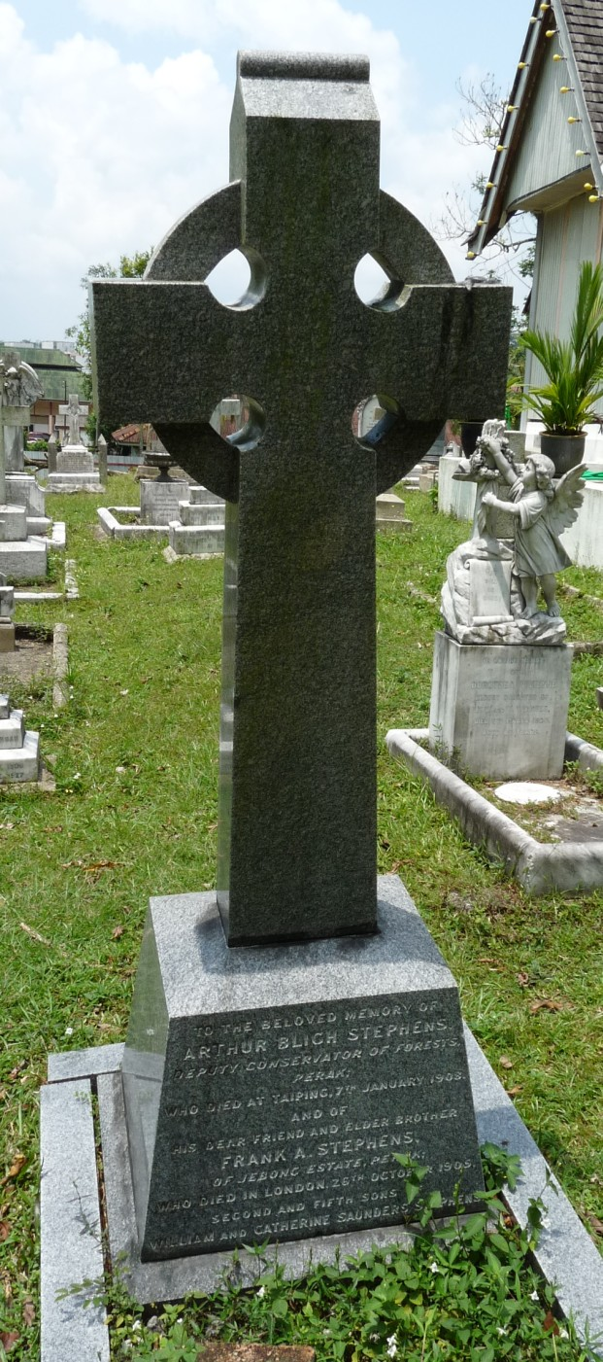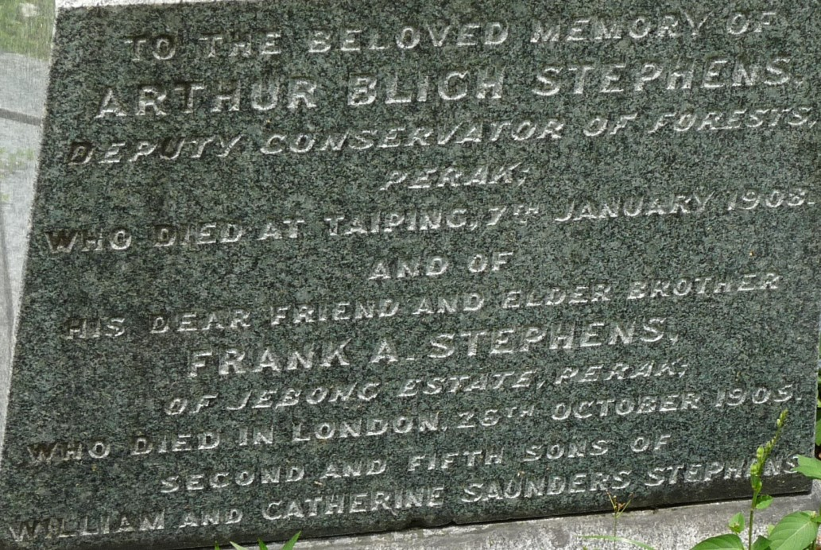
(Sumber gambar: Chris Nelson @ Find a Grave, 9 Mar 2010: |"Arthur Bligh Stephens").
Pada 5 Februari 1909 (kira-kira setahun selepas kematian), sebuah monumen peringatan telah didirikan di gereja tersebut: “A handsome Memorial Brass in an oak frame has recently been erected in All Saints Church, Taiping, to the memory of the late Mr A. B. Stephens, with the following inscription:-
In affectionate memory of
ARTHUR BLIGH STEPHENS,
Deputy Conservator of Forests, Perak,
who died in Taiping
On January 7th, 1908.
Aged 52 years.
This tablet was erected by
his Brother Officers.” (Sumber: The Singapore Free Press and Mercantile Advertiser2, 5 February 1909, Page 4: |"Untitled").
Selain itu, terdapat juga usaha pembinaan padang kriket di Taiping, sempena dua beradik Stephens ini: “Several donations have been received both in Ipoh, Batu Gajah, Kampar and Tapah, towards the building of the Cricket pavilion in Taiping, in memory of the brothers Frank and Arthur B. Stephens, who did so much for sport in the F.M.S. during their lifetime.” (The Straits Times, 6 May 1908, Page 8: |"Notes in General").
A.B. Stephens kini tersenarai sebagai:-
- Pengumpul Tumbuhan di pustaka Nationaal Herbarium Nederland |"Stephens, Arthur Bligh".
- Pengumpul Tumbuhan di pustaka JSTOR: |"Global Plants: Stephens, Arthur Bligh (1855-1908)".
- Ahli Botani di pustaka Harvard: |"Harvard University Herbaria & Libraries: Index of Botanists".
Laman Utama | 1900-1909 | 1910-1919 | 1920-1929 | 1930-1939 | 1940-1949 | 1950-1959 | 1960-1969 | 1970-1979 | 1980-1989 | 1990-1999
Siri Cebisan Sejarah: | Bangi | Gambang | Hutan | Ipoh | Kajang | Kuala Lumpur | Kuantan | Pulau Pinang | Hubungi Kami
Selain petikan dan sumber yang dinyatakan, rencana ini telah diusahakan oleh TMK Pulasan, di bawah kelolaan Syahrul Sazli Shaharir <sazli@pulasan.my>. Pengakuan penting: Kami bukan ahli sejarah! Sila klik di sini untuk penjelasan lanjut.

